**OPERATING SYSTEM**

**LAB ASSIGNMENT – V**

**[4ITRC2]**

Name: Raghav Maheshwari

Roll No: 23I4057

Branch: IT - ‘A’

**Lab Assignment 5**

**Aim**: To create C programs for the different scheduling algorithms.

**To perform**: Create and execute C programs for following CPU Scheduling Algorithms:

1. **First Come First Serve (FCFS)**

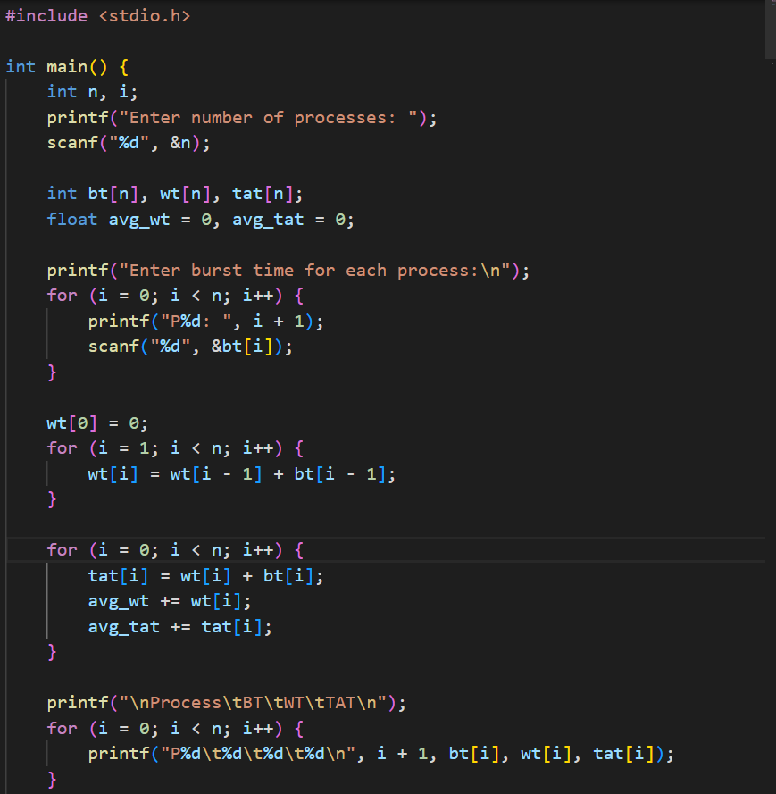

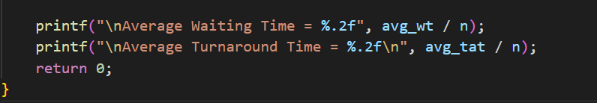

Output :

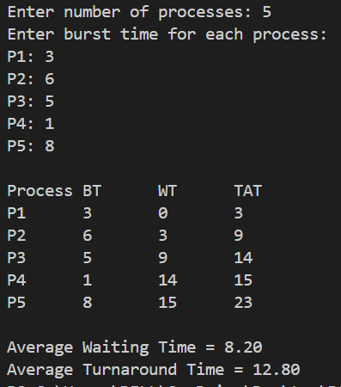

1. **Shortest Job First (SJF) :**

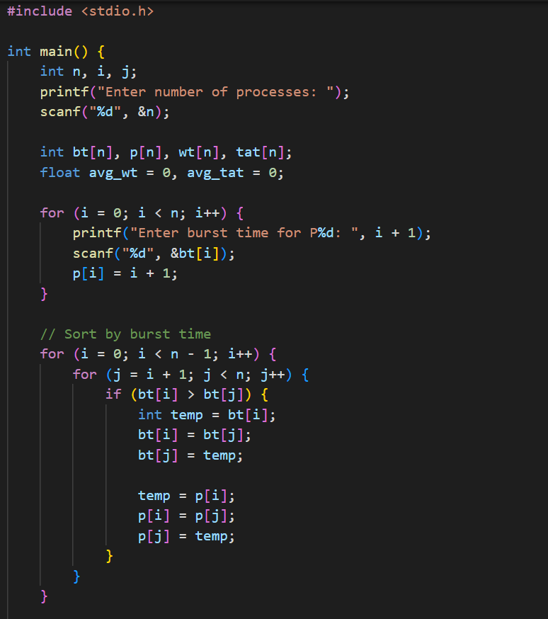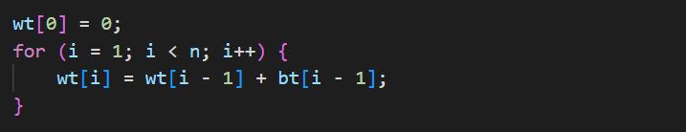

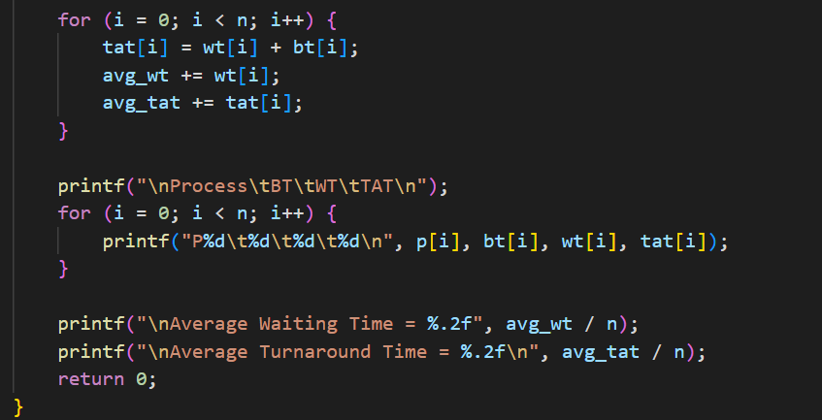

Output:

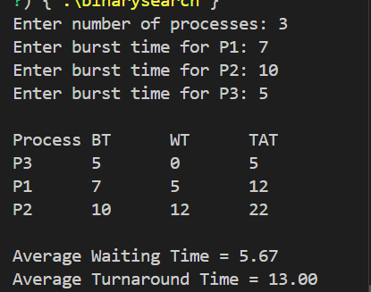

1. **Round Robin Scheduling :**

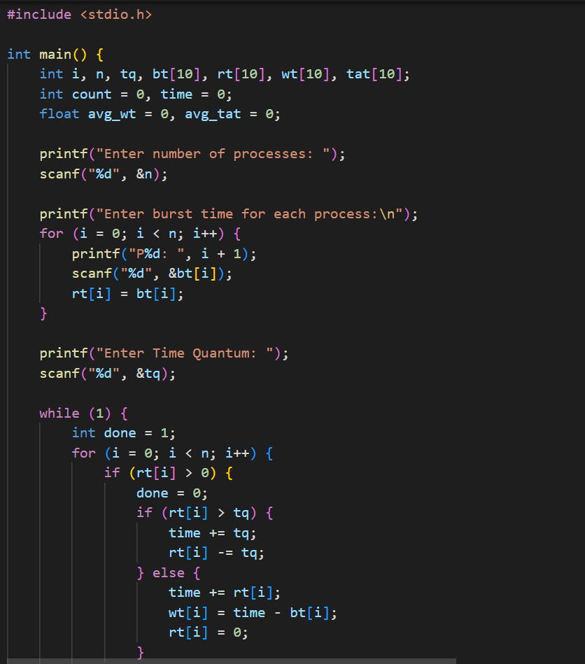

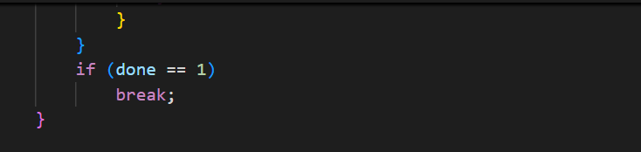

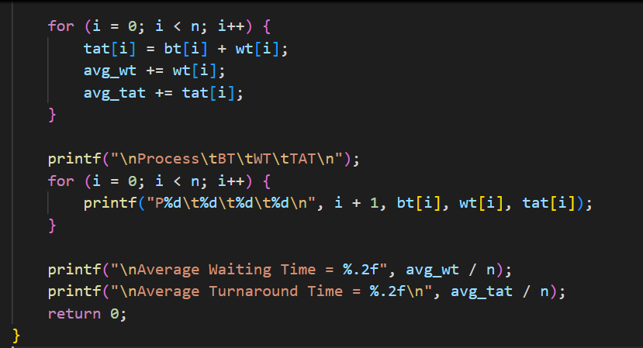

Output:

